
Coordinated Response to Health Canada’s
Consultation: Modernizing the framework for clinical trials
Deadline for Comments: April 19, 2026

To comment on the proposed regulations, submit your comments through the https://gazette.gc.ca/rp-pr/p1/2025/2025-12-20/html/reg2-eng.html
Please note that you can submit your comments anonymously or as an individual/organization (login or create an account – 5-minute procedure).
Helpful hints:
- The entire process takes 15-30 minutes.
- At the last step, you will have an option to attach up to three documents. We recommend that you attach the following documents: https://orionhra.egnyte.com/fl/gfFkmjhmB6k3 (password: w0KVVP6xH70k)
There are 10 sections of the consultation document. Below please find the coordinated response to the appropriate sections relevant to our initiative’s domain of expertise (feel free to copy/paste directly into the comments section of the government’s consultation platform):
1. General Comment 3
2. Executive Summary 5
3. Issues 6
4. Background 7
5. Objective 8
6. Description 9
7. Regulatory Development 11
8. Regulatory Analysis 12
9. Implementation, compliance and enforcement, and service standards 14
10. Proposed Regulatory Text 17

1. General Comment

Our comment:
Health Canada’s modernization proposal is necessarily oriented toward the regulation of drugs and clinical trial sponsors. Our comments are offered from a complementary but distinct vantage point: the protection of individuals who participate in research, and the governance systems required to ensure that protection is real, consistent, and independently verified.
Health Canada’s current inspection framework appropriately evaluates compliance with the Food and Drugs Act and applicable Good Clinical Practice requirements. However, inspections do not extend to a systematic assessment of the institutional human research protection infrastructure responsible for safeguarding research participants. While inspectors verify that REB approval was obtained and that informed consent documentation is present, there is no routine evaluation of institutional conflict-of-interest management, research participant complaint and reporting mechanisms, quality assurance systems, leadership accountability structures, or continuous oversight processes. As a result, regulatory oversight confirms protocol-level compliance but does not assess whether the broader protection ecosystem is robust, independent, and functioning effectively.
Incorporating a nationally recognized Human Research Protection Program (HRPP) accreditation framework into Canada’s modernization strategy would address this structural gap. HRPP accreditation evaluates the entire institutional system responsible for research participant protection - including governance, accountability, training, quality improvement, and conflict management - through standardized external review. Embedding such a framework would strengthen public confidence and align regulatory modernization with a system-level approach to research participant protection.
In this context, proposals framed primarily in terms of efficiency and reduction of administrative burden warrant careful calibration. Where comprehensive protection governance is absent or unverified, processes sometimes characterized as “red tape” may in fact represent the only functioning safeguards linking sponsors, institutions, and research participants. Efforts to accelerate approvals or streamline oversight without first strengthening institutional protection infrastructure risk making research faster, but not more protective. Recently, the Australian government’s Commission on Safety and Quality in Health Care adopted Canada’s program for accreditation (Human Research Accreditation Canada; HRA Canada). At the time of this writing, national standards similar to those of Human Research Standards Organization (HRSO) are currently in development in Australia, upon which an accreditation program will be established. This trajectory illustrates how strengthened governance frameworks can support both efficiency and research participant protection.
Modernization that focuses solely on regulatory efficiency without strengthening oversight of research participant protection infrastructure risks entrenching existing structural blind spots.

2. Executive Summary

Our comment:
The following high-level observations are offered on the framing of the proposed modernization initiative, as they inform the more detailed comments that follow:
While the Executive Summary emphasizes participant safety as a core objective, it does not explain how improved protection will be demonstrated, measured, or independently verified under the proposed framework.
While Canada relies heavily on REBs for research participant protection, there is currently no national system to independently verify that institutions conducting research have comprehensive governance, accountability, and protection systems in place. As a result, research participant protection is largely assumed rather than demonstrated through objective, standards-based oversight such as through Human Research Protection Program (HRPP) Accreditation.
The Executive Summary frames ethics oversight primarily as an enabler of efficiency and coordination, rather than as an independent protective function in its own right. Centralization and harmonization are presented as unqualified improvements; however, without explicit reference to standards (National Standards of Canada), independence, and accountability (HRPP Accreditation), centralization risks amplifying existing variability rather than correcting it.
3. Issues

Our comment:
The “Issues” section primarily frames limitations in the current clinical trials framework in terms of regulatory inefficiency, inflexibility, and barriers to innovation and trial volume. While these are important considerations, the analysis largely assumes that existing ethics oversight mechanisms adequately protect research participants, without examining whether participant protection is consistently achieved in practice.
From a participant protection and governance perspective, long-standing variability in ethics review quality, independence, and accountability represents a systemic issue that is not addressed in the problem framing.

4. Background

Our comment:
No comment.

5. Objective
Our comment:
The proposed framework introduces stronger regulatory controls over sponsors and trial conduct. However, it continues to frame participant protection primarily as a REB function. It does not address the broader reality that research participant protection is an institutional responsibility - delivered through a Human Research Protection Program (HRPP) with shared accountability across the organization, not a single committee.
In modern governance models, REBs function within comprehensive institutional protection systems that include leadership accountability, quality management, training, monitoring, incident response, and independent verification - rather than serving as the sole safeguard.
This reflects a paradigmatic gap: the framework optimizes trial authorization and conduct, but it does not modernize the institutional systems that protect the people who are asked to participate.

6. Description

Our comment:
Although the proposed framework introduces significant new regulatory controls over sponsors and trial conduct, the role and structure of ethics oversight remain largely unchanged, despite their central importance to research participant protection.
Streamlining ethics review through national REBs may improve administrative coordination; however, without independent, standards-based evaluation of both committees and the institutional systems within which they operate, centralization alone cannot ensure consistent research participant protection.
In addition, while the proposed Regulations introduce the designation of national REBs to streamline ethics review across sites, no objective measures of quality, performance, or adherence to nationally recognized standards are articulated as part of the designation process. The proposed approach relies on a subjective administrative listing rather than an objective, independent, standards-based assessment.
Given the central role that national REBs would play in approving protocols and informed consent across multiple sites, the absence of transparent, objective quality criteria and ongoing oversight mechanisms raises concerns regarding consistency, accountability, and public confidence in ethics review. Modern governance models worldwide increasingly rely on independent evaluation against established national standards for Human Research Protection Programs (HRPPs). This is the type of independent, standards-based quality assessment provided through Human Research Accreditation Canada’s (HRA Canada) HRPP accreditation program.
While enabling the use of national REBs may reduce duplicative ethics reviews and improve administrative efficiency, it does not address the broader institutional responsibility for research participant protection. Ethics review - whether local or centralized - represents only one component of a comprehensive human research protection system.
Modern oversight models increasingly recognize research participant protection as a shared organizational responsibility, supported through governance structures, quality systems, training, compliance mechanisms, and continuous improvement processes, as embodied in Human Research Protection Program (HRPP) accreditation frameworks that already exist in Canada through Human Research Accreditation Canada (HRA Canada), and internationally.
The proposed Regulations continue to focus oversight on committees rather than on institutional systems of accountability, leaving a key gap in the modernization of clinical trial governance.

7. Regulatory Development
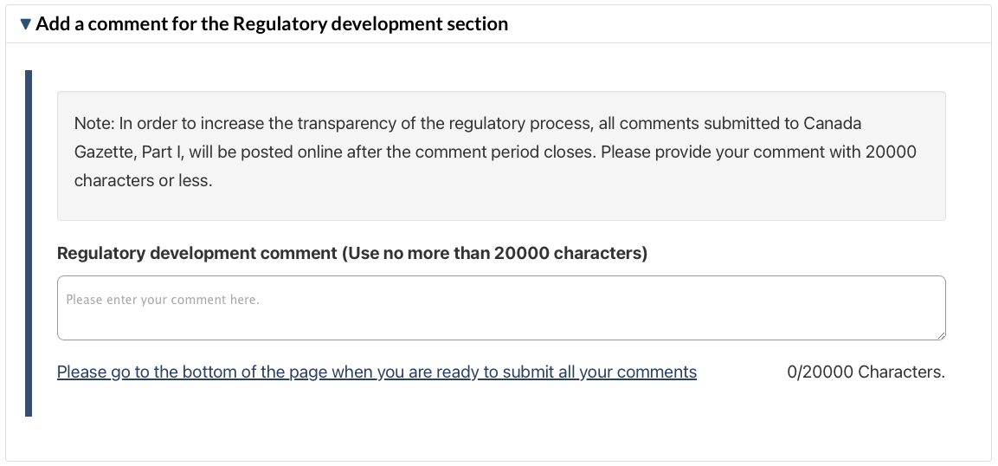
Our comment:
The proposed framework places strong emphasis on efficiency, regulatory flexibility, international alignment, and enabling innovation. While research participant safety is consistently cited as a priority, research participant protection is framed largely as an assumed outcome of regulatory controls rather than as a system requiring its own governance architecture, standards, and independent oversight.
An established model already exists in Canada to address this gap - Human Research Protection Program (HRPP) accreditation through Human Research Accreditation Canada (HRA Canada). It operates independently of government, making adoption cost-neutral from a federal perspective and avoiding the need to create new federal accreditation infrastructure. This initiative is the result of over two decades of expert, largely federally funded work in Canada that produced National Standards of Canada for human research and the creation of an HRPP accreditation program based on those standards.
Several federal departments (Privy Council, DND, NRC) already require that their research and REB contractors exist within accredited Human Research Protection Programs (HRPPs).
The groundwork is mature and ready to be used within existing federal health authorities and levers.

8. Regulatory Analysis

Our comment:
While the cost-benefit analysis provides a detailed assessment of sponsor-level efficiencies and regulatory resource impacts, it remains narrowly focused on administrative and operational changes within the existing clinical trial framework. The analysis largely quantifies savings associated with labelling flexibilities and selective record retention, alongside increased regulatory oversight costs related to applications, amendments, notifications, and terms and conditions.
However, the analysis does not account for the economic and risk-mitigation value of strengthening research participant protection as a system-level governance outcome. The proposed framework introduces significant new regulatory controls over sponsors and trial conduct, yet continues to rely primarily on REBs as the central mechanism for research participant protection, without addressing the broader institutional responsibility for research participant protection through a comprehensive Human Research Protection Program (HRPP) approach and its accreditation.
Governance mechanisms such as Human Research Protection Program (HRPP) accreditation - which already exists in Canada through an independent, cost-neutral national program - are designed to embed research participant protection across the entire research enterprise, including leadership accountability, quality systems, training, compliance infrastructure, and continuous improvement. These systems can generate tangible economic value by:
1. Reducing duplication and inefficiencies through coordinated and reliance-based ethics review models (similar to the “single review” efficiencies referenced in international frameworks such as SMART IRB in the United States);
2. Improving inspection readiness and minimizing operational disruptions associated with regulatory findings;
3. Reducing the likelihood of serious compliance failures that lead to trial suspensions, delays, or corrective actions; and
4. Mitigating downstream institutional risk and costs associated with preventable participant harm, disputes, and reputational damage.
None of these system-level benefits are reflected in the current quantitative or qualitative analysis.
In addition, while the proposed Regulations are expected to attract additional clinical trials and investment, the analysis does not consider how stronger institutional governance and standardized protection programs could further enhance Canada’s competitiveness by increasing international confidence in the quality, consistency, and accountability of its human research oversight environment.
As a result, the net monetized benefit presented in the analysis (approximately $313,926 PV over 10 years) likely understates the broader economic and societal value that could be achieved through a more comprehensive governance approach to research participant protection.
Health Canada should consider incorporating the role and value of institutional human research protection systems - including Human Research Protection Program (HRPP) accreditation - as a complement to regulatory oversight. Doing so would better reflect the shared responsibility for research participant protection, align with international best practices, and capture a fuller picture of both the economic and risk-reduction benefits associated with modernizing Canada’s clinical trials ecosystem.

9. Implementation, compliance and enforcement, and service standards
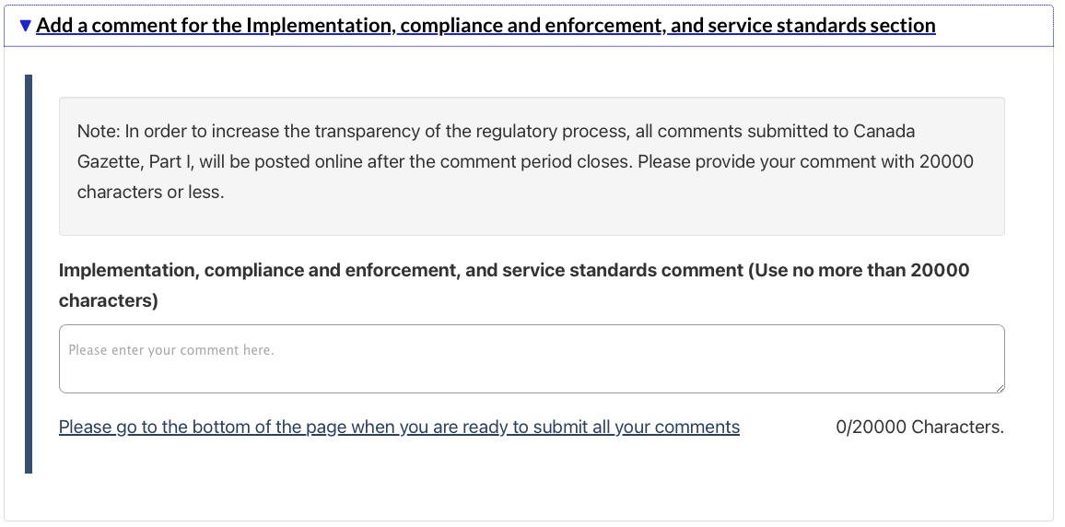
Our comment:
The emphasis on risk-based compliance, expanded oversight of service providers, enhanced enforcement tools, and strengthened guidance reflects a positive shift toward more active regulatory supervision of clinical trial conduct. These measures may improve regulatory responsiveness and data integrity while providing Health Canada with greater flexibility to address non-compliance in a targeted manner.
However, the proposed implementation and enforcement approach continues to position research participant protection primarily as a function of regulatory oversight and compliance actions, rather than as a shared institutional responsibility embedded within comprehensive governance systems. While inspections, enforcement tools, and guidance are important components of oversight, they are inherently reactive mechanisms.
Health Canada’s inspection framework evaluates compliance with the Food and Drugs Act and Good Clinical Practice requirements but does not extend to systematic assessment of the institutional human research protection infrastructure responsible for safeguarding participants. Inspectors confirm REB approval and the presence of informed consent documentation, yet there is no routine evaluation of institutional conflict-of-interest management, participant complaint mechanisms, quality assurance systems, leadership accountability structures, or continuous oversight processes. As a result, implementation and compliance activities verify protocol-level adherence without assessing whether the broader protection ecosystem is robust, independent, and functioning effectively.
Incorporating the existing nationally recognized Human Research Protection Program (HRPP) accreditation framework into Canada’s modernization strategy would complement regulatory enforcement by introducing proactive, system-level verification of institutional protection capacity. HRPP accreditation evaluates governance, accountability, training, quality management, and conflict oversight through standardized external review - strengthening the very infrastructure upon which effective compliance ultimately depends.
In other areas involving risk, Canada relies on independent, arm’s-length accreditation systems to protect patients (healthcare), laboratories, and animals in research. These systems are not run by government, but governments rely on them to verify quality and safety. Human research participants are the exception.
An REB is like the cockpit crew of an airplane: skilled, essential, and performing a critical role. But safety depends on the entire system around them - training, oversight, reporting, inspections, and accountability. We would never accept airlines self-inspecting their own fleets without independent verification.
Yet this is effectively how human research is governed today: institutions attest to their own compliance, rather than operating within a verified, system-level framework that increases efficiency and consistency.
Modern human research protection frameworks increasingly emphasize proactive, system-level accountability through institutional programs that integrate ethics review, quality management, training, monitoring, incident response, and continuous improvement - such as the model established through Human Research Protection Program (HRPP) accreditation already in use in Canada and internationally.
The absence of any reference to institutional protection systems or governance frameworks in the implementation and compliance strategy represents a missed opportunity to strengthen research participant protection in a sustainable and preventive manner. Reliance on inspections and enforcement alone cannot substitute for robust internal systems designed to identify risks early, support ethical conduct across organizations, and ensure consistent protection of research participants across all trial activities.
Additionally, while service standards focus appropriately on authorization timelines and regulatory efficiency, no comparable standards or expectations are articulated regarding the quality and effectiveness of research participant protection systems at the organizational level even though these standards exist (National Standards of Canada).
A truly modernized clinical trials framework would complement Health Canada’s enhanced regulatory powers with explicit recognition of institutional Human Research Protection Programs (HRPPs) and governance structures as foundational elements of research participant safety and ethical research conduct.

10. Proposed Regulatory Text
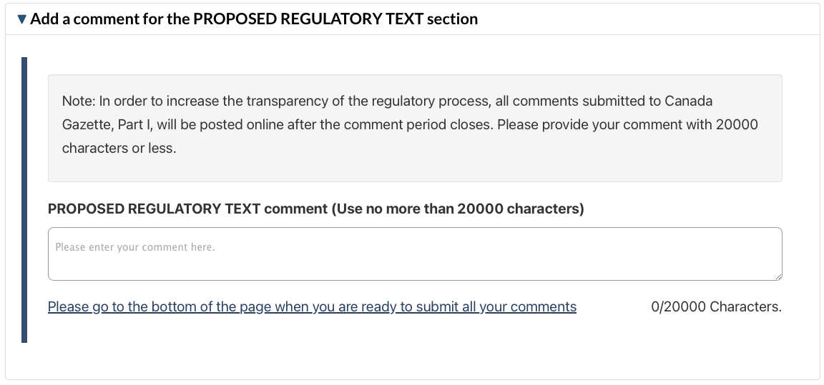
Our comment:
Please see comments above as they relate to the proposed regulatory text.

